**Detect the Virtualization support on Windows 10**

Check if Hardware Virtualization Enabled

1.Task Manager-Performamce Tab🡪CPU🡪Virtualization Enabled.

2. Run > msinfo32

The first page shows whether virtualization is enabled in BIOS (firmware).

[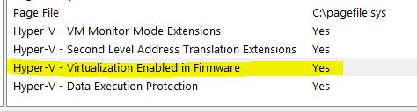](https://i.stack.imgur.com/DPEpY.jpg)

Software Environment—Services🡪Hyper-V Virtual Management.

3.Run systeminfo in administrator mode

4. If you have Intel Chipset, download the utility [Intel® Processor Identification Utility – Windows* Version](https://downloadcenter.intel.com/download/7838), from <https://downloadcenter.intel.com/download/28539?v=t> its a .msi file, so you will have to install it and run from C:\Program Files (x86)\Intel Corporation\Intel Processor Identification Utility dir.

In Intel Technologies tab, under Supported Intel Advanced Processor Technology you should see Intel Virtualization Technology as Yes. If you see this, your CPU supports Virtualization as shown in the below screenshot.

## 5. Microsoft® Hardware-Assisted Virtualization Detection Tool –havdetectiontool.exe

## NOT supported on Windows 10

<https://www.microsoft.com/en-us/download/details.aspx?id=592>

--------------